InfoEx 3.0 Documentation
How to migrate an operation from the old CAAML-based
InfoEx system to the new InfoEx system
Version 0.2 (Sept. 24, 2013)
User Levels:  Super User  Operation Administrator  Obs Moderator  User | Connectivity:  Online  Offline

OBJECTIVE:
This document describes how to migrate the locations from the old CAAML-based InfoEx system to the new InfoEx system.
BACKGROUND:
Migrating an operation from the old CAAML-based system into the new InfoEx system is an involved process that requires great care to ensure that the historic observations are preserved as much as possible, so that InfoEx subscribers will have access to their historic observations through the new system. The complete migration process consists of the following steps:
- Extraction of historic observations from eXist database in CAAML 3.0.3 format.
- Extraction of 2012/13 location catalog from eXist database in CAAML 3.0.3 format.
- Listing of all locations of 2012/13 location catalog and counting of associated observations.
- If there is a mismatch between the total number of location references used in historic observations and the location references supported by the 2012/13 location catalog, retrieve all location IDs and names from historic observation files.
- Working with operator to resolve any issues in the existing location catalog (e.g., duplications of locations).
- Updating location references used in historic observations with updated location IDs.
- Updating location catalog (e.g., deleting of obsolete locations, changing of observation types, name changes).
- Working with operator to create required geometries for all the locations in the updated location catalog in KML format.
- Uploading of the updated location catalog in CAAML 3.0.3 format together with the associated geometries in KML format to the new system.
- Manually associating geometries to locations that were not automatically matched.
- Uploading any new locations to the system directly from KML files.
- Manually updating the hierarchy structure of the location tree.
Pascal Haegeli has developed a series of XSLT and R programs to automate the extraction and examination of the historic CAAML 3.0.3 format (steps 1 to 7).
In this document we will only describe uploading process of the up-to-date CAAML and KML files (steps 9 to 12).
STEP-BY-STEP DESCRIPTION:
- Log into the InfoEx system with an account that has Super User privileges.
- You can, but you do not have to select an operation on the first screen after logging in.
- Go to the administration menu (cog wheel) in the top right concern of the application next to your user name and select 'Load Utilities' (Fig. 1).
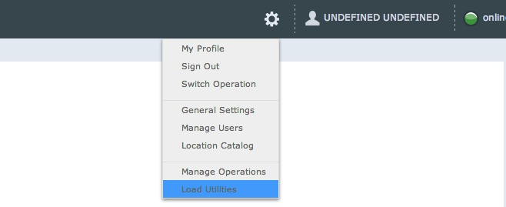
Fig. 1: Administration menu
- TASK 1: Merge the updated CAAML location catalog with the related location geometries from a KML file and upload it to the new system.
  - Select the 'Load Location Catalog' tab (Fig. 2).
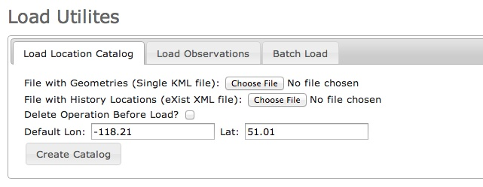
Fig. 2: Load Location Catalog user interface
  - Click on the first 'Choose File' button and select the KML file for the upload. This KML needs to contain the appropriate geometries for all of the locations included in the CAAML location catalog. The locations included in the KML file can be organized in folders. Since the location matching between the CAAML and KML files is done via name, it is crucial that the names of the equivalent locations are the same in both files. If there are locations with the same name (e.g., a ski run and a weather site with the same name), it is important to make these names unique for the import process.
NOTE: Note that the system currently does not support multi-geometries (i.e., multiple, separate polygons, lines or points associated with a single location (SAFE-772 - Aug. 13).
Workaround: Please contact Pascal Haegeli for how to combine the individual polygons to a workable polygon.
  - Click on the second 'Choose File' button and select the CAAML 3.0.3 file for the upload.
  - If a location catalog already exists for this operation and you are want to replace it, check 'Delete Operation Before Load'. Please note that it is only possible to delete an operation if there are no users or no observations associated with it.
  - Specify a default longitude and latitude for locations that cannot be matched with a KML geometry.
  - Click on 'Create Catalog'. This will:
    - Create a new operation record based on the information included in the <OPERATION> element in the CAAML. 3.0.3 file.
    - Create the location catalog for the new operation
  - Depending on the size of the files, uploading and importing them into the new system might take a few minutes. A pop-up window will inform you about the completion of the process. If the process fails, the pop-up window will contain any related error messages.
BUG: There is currently no roll-back in the import functionality. If the import process fails due to an issue in the KML or CAAML files, all the locations processed previous to the failure remain in the system (SAFE-845 - Sept. 23)
Workaround: Fix the files and upload again with 'Delete Operation Before Load' checked.
  - To view the location catalog of the new operation, log out of the system and log back in with your super user account.
  - Select the new operation from the drop-down menu on the first page after the log in.
  - Go to the administration menu (cog wheel) in the top right concern of the application next to your user name and select 'Location Catalog'. This will open the location catalog of the new operation.
BUG: The Google Earth instance does not always load properly (SAFE-836 - Sept. 22).
Workaround: Restart the browser and log back into the system.
  - Locations, for which it was not possible to find the matching geometry during the upload process are marked with a '**' pre-fix to their names in the location catalog. The system automatically associates locations with missing geometries with the default point location specified in Step e. Any locations that were only found in the KML file are completely ignored in the upload process.
NOTE: Please note that the default point location does not necessarily represent a valid geometry for the location type of the location. Any attempt to modify the location (e.g., change name, change location within location hierarchy) will fail until the location is associate with a valid location geometry. See How to add location to your operation for more detail.
- TASK 2: Manually uploading geometries for individual locations.
  - Select an operation on the first screen after logging in.
  - Go to the administration menu (cog wheel) in the top right concern of the application next to your user name and select 'Location Catalog'. This will open the location catalog of the new operation.
BUG: The Google Earth interface does not always load properly (SAFE-836 - Sept. 22).
Workaround: Restart the browser and log back into the system.
  - Find the location you would like to edit in the location tree on the left side of the Location Catalog screen.
  - Right click (ctrl+click on Mac) on the location and select Edit (Fig. 3). This will open up a pop-up window with a second Google Earth user interface.
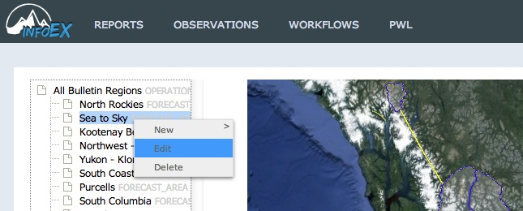
Fig. 3: Location menu in location catalog
BUG: Sometime the menu options in the location tree do not seem to be enabled (SAFE-841 - Sept. 22).
Workaround: Leave the location catalog page and return to it or completely restart the browser.
BUG: The second Google Earth interface does not always load properly (SAFE-836 - Sept. 22).
Workaround: Restart the browser and log back into the system.
  - Edit the information in the following fields as desired:
    - Name (required):
Delete the '**' prefix
    - Abbreviation (required):
Add or modify an abbreviation for the location that will be in tabular InfoEx report
    - Description (optional):
Add or modify an optional description of the location
    - External ID (optional):
The external ID of the location is required if the operation submits their observations from an external database system via the API. The external ID is also required for locations that already existed in the legacy CAAML driven InfoEx and have historic observations associated with them. It is strongly recommended that you leave this field as is.
    - Location geometry (required):
There are two options for adding a geometry to a location:
      - Drawing it directly in the Google Earth interface:
NOTE: Drawing directly in the Google Earth map has not been implemented yet (SAFE-132 - Sept. 22).
      - Importing the geometry from a KML file:
        - Create a KML file in Google Earth with the appropriate geometry for the location. See How to add locations to your operation for more detail on valid location geometries. Ensure that the location is clearly visible when you save it as the KML file.
NOTE: Note that the system currently does not support multi-geometries (i.e., multiple, separate polygons, lines or points associated with a single location (SAFE-772 - Aug. 13).
Workaround: Please contact Pascal Haegeli for how to combine the individual polygons to a workable polygon.
        - At the bottom of the location pop-up window in the InfoEx application, click on 'Choose File'
        - Navigate to the KML file that contains your geometry in the file dialog, select the file and click on 'Open'.
        - Navigate to the location of your geometry in the Google Earth map of the InfoEx application. The location will appear in the same fashion as you saved it in Google Earth.
        - Click on the geometry to select it. You will receive a confirmation message in the Google Earth map 'selected this feature: <Name of geometry as saved in the KML file>'.
      - Click on Update to commit your edits to the system and close the pop-up window.
BUG: Even though the edits to the location are committed to the system, the pop-up window does not always close. (SAFE-795 - Aug. 24).
Workaround: After clicking on add, click on cancel to close the window.
BUG: The main Google Earth map currently does not instantly update after any edits to the location catalog (SAFE-831 - Sept. 22).
Workaround: To see the update location geometry in the Google Earth map, exit the location catalog page of the application (e.g., go to reports) and come back to the location catalog page to refresh it. The map will automatically zoom to the operation area of the operation and display it in the InfoEx default symbology. If this does not work, you might have to completely sign out of the application and sign back in to see the changes.
- TASK 3: Uploading new locations directly from KML files.
  - Go to the administration menu (cog wheel) in the top right concern of the application next to your user name and select 'Load Utilities'.
  - Select the 'Batch Load' tab (Fig. 4).
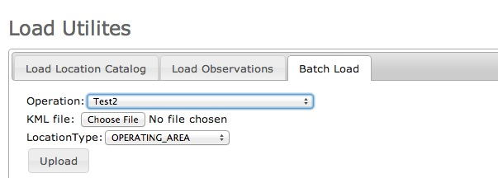
Fig 4: Batch load user interface
  - Select the operation you would like to add locations to.
  - Click the 'Choose File' button and select the KML file with the locations to be uploaded. This file can only contain locations of the same type.
NOTE: You can only upload locations for a single location type (i.e., ski runs) at one time. If you have to upload multiple location types, you need to split them up into separate KML files are repeat the process for each location type.
  - Select the correct location type from the drop down list.
  - Click on the 'Upload' button.
  - Depending on the size of the files, uploading and importing them into the new system might take a few minutes. A pop-up window will inform you about the completion of the process. If the process fails, the pop-up window will contain any related error messages.
BUG: There is currently no roll-back in the import functionality. If the import process fails due to an issue in the KML or CAAML files, all the locations processed previous to the failure remain in the system (SAFE-845 - Sept. 23)
Workaround: Fix the files and upload again with 'Delete Operation Before Load' checked.
  - To view the updated location catalog, go to the administration menu (cog wheel) in the top right corner of the application next to your user name and select 'Location Catalog'.
BUG: The Google Earth instance does not always load properly (SAFE-836 - Sept. 22).
Workaround: Restart the browser and log back into the system.
- TASK 4: Changing the structure of your location hierarchy.
  - Go to the administration menu (cog wheel) in the top right concern of the application next to your user name and select 'Location Catalog'.
  - Expand the location tree an click on a location that you would like to move within the location hierarchy. The Google Earth map will automatically zoom to this location.
  - In most cases, you are interested in moving a location (i.e., Ski Run, Av Path) into the appropriate forecast area or operating zone. In the Google Earth map, click on the background in the close vicinity of the location. A popup balloon will show the name of the local operating zone or forecast area.
  - In the location tree on the left side of the screen, drag the location into the desired parent location.
NOTE: Any attempt to modify the location (e.g., change name, change location within location hierarchy) will fail unless the location is associate with a valid location geometry. See How to add location to your operation for more detail.
RELATED DOCUMENTS
- How to specify the sort order in the tabular InfoEx report
- How to add location to your operation.
FUNCTIONALITY TESTED BY:
- Sept. 23: Pascal Haegeli / QA Server / Test Version 0.27.00

